Supplementary File 1: The inclusion and exclusion criteria
On 11/07/2024, the guidelines for generating the inclusion and exclusion criteria were discussed, and this used set theory as shown in Figure 1.

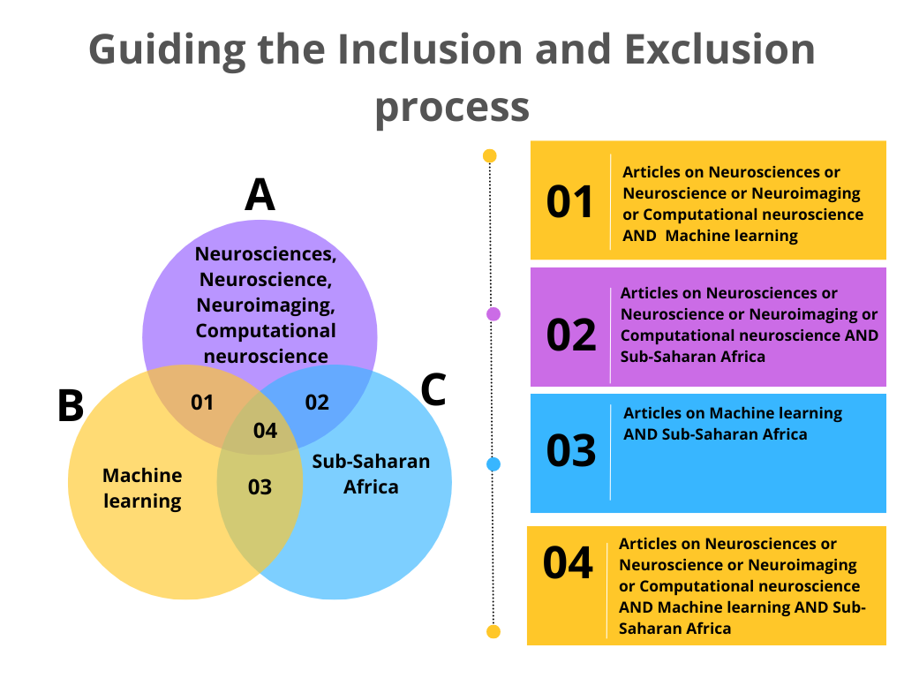
Figure 1: Shows the guidelines for the process followed when including and excluding manuscripts. The final manuscripts considered are AnBnC.

On 01 Aug 2024 (the inclusion and exclusion criteria were determined by three co-authors).
We exclude;
- Review papers, commentaries, and perspectives.
- Articles in Neurosciences Using Machine Learning outside Sub-Saharan Africa
- Articles co-authored by a Sub-Saharan Africa-affiliated institution, but the dataset is outside Sub-Saharan Africa.
- Any papers on animals
- Abstracts
- Authors' biographies or index
- Publisher general elections, e.g., https://dl.acm.org/doi/pdf/10.1145/3652030
- Books and book chapters
- Notes
- Interviews
- Dissertations
- Editorial
- Table of contents
- Summer schools
- News
- Reports (annual and conference reports)
- Society briefs
- Conference programs
- Tutorials
- Obituary
- Cover page
- Studies that do not specify the dataset collection location (we emailed the corresponding authors to inquire about the dataset location and excluded those studies where the authors did not respond).
- Retracted articles
- Conference Proceedings (as advised by the computer science librarian at UCT, since ACM fails to extract conference proceedings articles but extracts only the full proceedings, which were hard to import into the Rayyan software)
For manuscripts included, observe the following criteria.

- The paper should be in Neurosciences.
- The paper should be on machine learning
- The paper should include data on the Sub-Saharan African population
- Needs to be on humans
- Only peer-reviewed original articles where the primary contribution is at the above intersection.
- Grey literature, e.g., Technical reports, where the primary focus is at the above intersection.
- Only papers in English (this means we shall not have papers in French-speaking countries) - which is a bias we need to highlight in our work

